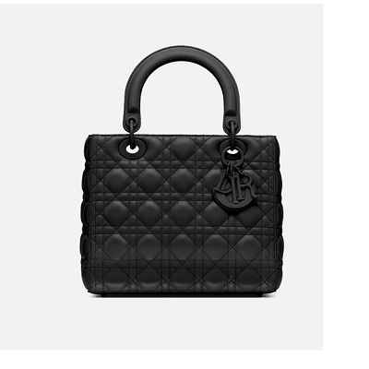

Lady Dior ultra-matte bag

PRODUCT DETAILS

**Jewelry in ultra matte-finish metal**

**Narrow adjustable shoulder strap**

**Carried in the hand, on the shoulder or across the body**

**Dimensions: 24 x 20 x 11 cm**